Backend Client: Query API

Abstract:
This query API provides an easy, one-stop source for the client app to pull data from the backend. Instead of using a GET request with a different URL address for every query that the client wants to make to the backend, the query API offers a single URL address to batch queries altogether in one request. The following API is geared for client usage of the backend.

The client accesses query by making a POST request (and filling in the parameters) through the route with our backend site with the following extension: "queries/new"
Parameters: An array of JSON dictionaries, where each dictionary is a query.
Returns: An array of JSON dictionaries, with results in the same respective order as the parameters.

Structure & Technical Details:
Functionally, the query controller is similar to the routes.rb layer of a Rails app. Though it is possible to access different functions of the Rails app through the different routes and its respective controllers, this Query API and consequent route provide a more efficient one stop route.

Implementation-wise, the query controller sits atop the other controllers to access model data, and queries of model data.

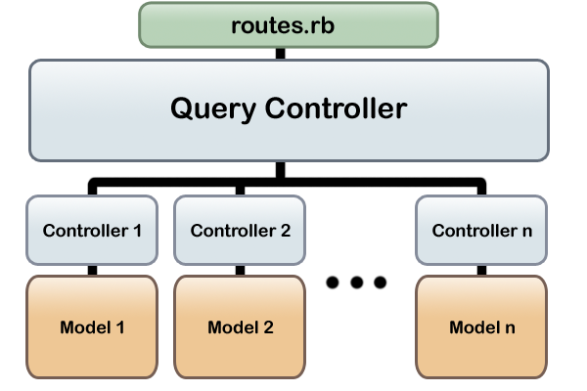

The backend is responsible for parsing through the array and JSON. It then routes the queries to the appropriate controllers and its method calls.

Format of Parameters (aka Query Inputs)
General Array Format of Parameters
[ {query 1}, {query 2}, …, {query n} ]
As noted, the input is an array of JSON dictionaries.
General Format for a Parameter Interior
{
“query”: string
“params”: {“param1”:value1, “param2”:value2, …, “paramn”:valuen}*
}
*Backend specifies what the "query" string is.

Format of Returns (aka Result Outputs)
General JSON Format of All Results
[ Query_Result1, Query_Result2, Query_Result3, …, Query_Resultn ]

The result of the queries are in the same respective order as the query parameters passed in-- also in the form of an array of JSON dictionaries.
General Format For a Result Interior
{
"query":string-- same name as the "query" in the input
"name":string-- simple name of the result for client to use
"result": [...]
}
The Query "result" itself is an array of JSON dictionaries-- and the formatting of those dictionaries will vary depending on the result.

Reference:
For help on JSON formatting, see: link

Current Queries:
- Leaderboard Rankings
  - Description:
    - All leaderboard queries have the same format. The following shows an example of one-- as well as a list of all the leaderboard queries currently available.
  - Parameters:
    - Query: “rankings_<title>”
    - Params:
      - “start_index” integer (default = 1)
      - “num” integer (default = 100)
  - Return Format:
    - [ {“udid”: string, “payload”: <value>, “rank”: int} ,…, {...} ]
    - "payload" is typed to the value for that user in that specific leaderboard. For example, payload will be a float for mph in a max speed leaderboard.
    - The entries are sorted in descending order by payload
  - Current Queries:
    - "rankings_carma_points"
    - "rankings_max_speed"
    - "rankings_avg_speed"
    - "rankings_total_distance"
    - "rankings_redlight_time"
    - "rankings_redlight_count"
    - "rankings_greenlight_count"
    - "rankings_avg_consumption"

- User Rank in a Leaderboard
  - Description:
    - Returns a single entry (in similar format as an entire leaderboard) but for the specific user specified.
  - Parameters:
    - Query: “user_rank_<title>” string
    - Params:
      - “udid” string
  - Return Format:
    - [{“udid”: string, “payload”: float, “rank”: int}]
    - payload: value is typed to the specific leaderboard.
  - Current Queries:
    - "user_rank_carma_points"
    - "user_rank_max_speed"
    - "user_rank_avg_speed"
    - "user_rank_total_distance"
    - "user_rank_redlight_time"
    - "user_rank_redlight_count"
    - "user_rank_greenlight_count"
    - " user_rank _avg_consumption"

- Average Speed of Location (box)
  - Description:
    - Returns the average speed in a box around a given gps coordinate
  - Parameters:
    - Query: “location_avg_speed_box”
    - Params:
      - “threshold” float (default = 0.0001389)
      - “latitude” float
      - “longitude” float
  - Return Format:
    - [ {“payload”: float, “count”: int, “user_count”: int} ]
    - payload: avg speed in miles per hour
    - count: number of points used to calculate payload
    - user_count: number of distinct users whose data was used to calculate payload

- Average Speed of Location (n closest points)
  - Description:
    - Returns the avg speed of the n closest readings to a given gps coordinate
  - Parameters:
    - Query: “location_avg_speed_points”
    - Params:
      - “n” integer (default = 10)
      - “latitude” float
      - “longitude” float
  - Return Format:
    - [ {“payload”: float, “count”: int, “user_count”: int} ]
    - payload: average speed of n closest locations
    - count: number of points
    - user_count: number of distinct users who provided the points

- Feeds Since Time
  - Description:
    - Returns all of the feeds for a user since a given time
  - Parameters:
    - Query: “feeds_since_time”
    - Params:
      - “time” datetime
  - Return Format:
    - [{“payload”: string, “time”: datetime}, … , {...}]
    - payload: message to display in the feed.

- Last N Feeds
  - Description:
    - Returns all of the feeds for a user since a given time
  - Parameters:
    - Query: “feeds_most_recent_n”
    - Params:
      - “n” integer
  - Return Format:
    - [{“payload”: string, “time”: datetime}, … , {...}]
    - payload: message to display in the feed.

- Achievements
  - Description:
    - Returns a master list of all available achievements in the database
  - Parameters:
    - Query: “achievements”
    - Params:
  - Return Format:
[ {"achievement":
{
"achievement_id":integer,
"achievement_name":string,
"carma_points":int,
"category":string,
"description":string,
"pic_address":string,
}
} , ..., {...} ]
    - "pic_address" will send the URL address of the achievement icon alone.

- User's Unlocked Achievements
  - Description:
    - Returns a list of all the achievements the user has gotten.
  - Parameters:
    - Query: “user_achievements”
    - Params:
      - “udid" string
  - Return Format:
[{"unlocked_achievement":
{
"achievement_id":int,
"achievement_name":string,
"carma_points":int,
"category":string,
"description":string,
"pic_address":string,
"pic_address_small":string,
"time_unlocked":datetime,
"udid":string,
"user_name":string
}
}, ..., {...} ]
    - "pic_address" will send the URL address of the achievement picture with the MINI logo wrapped around it.
    - "pic_address_small" sends a different URL address with a smaller resolution version of the "pic address" image

Sample Usage:

Here is a test query which does all of the individual queries once.

[
{"query":"rankings_max_speed","params":{}},
{"query":"rankings_avg_speed","params":{}},
{"query":"rankings_total_distance","params":{}},
{"query":"rankings_redlight_time","params":{}},
{"query":"user_rank_max_speed","params":{"udid":"user1"}},
{"query":"user_rank_avg_speed","params":{"udid":"user1"}},
{"query":"user_rank_total_distance","params":{"udid":"user1"}},
{"query":"user_rank_redlight_time","params":{"udid":"user1"}},
{"query":"feeds_since_time","params":{"udid":"user1","iphone_time":3.0}},
{"query":"feeds_most_recent_n","params":{"udid":"user1","n":1}}

]

